**MuhammadFawwaz**

**22F-8813**

**Farazulkhaf**

**22F-3356**



EcoCommute Deliverable 2

1. **Create Driver Profile**

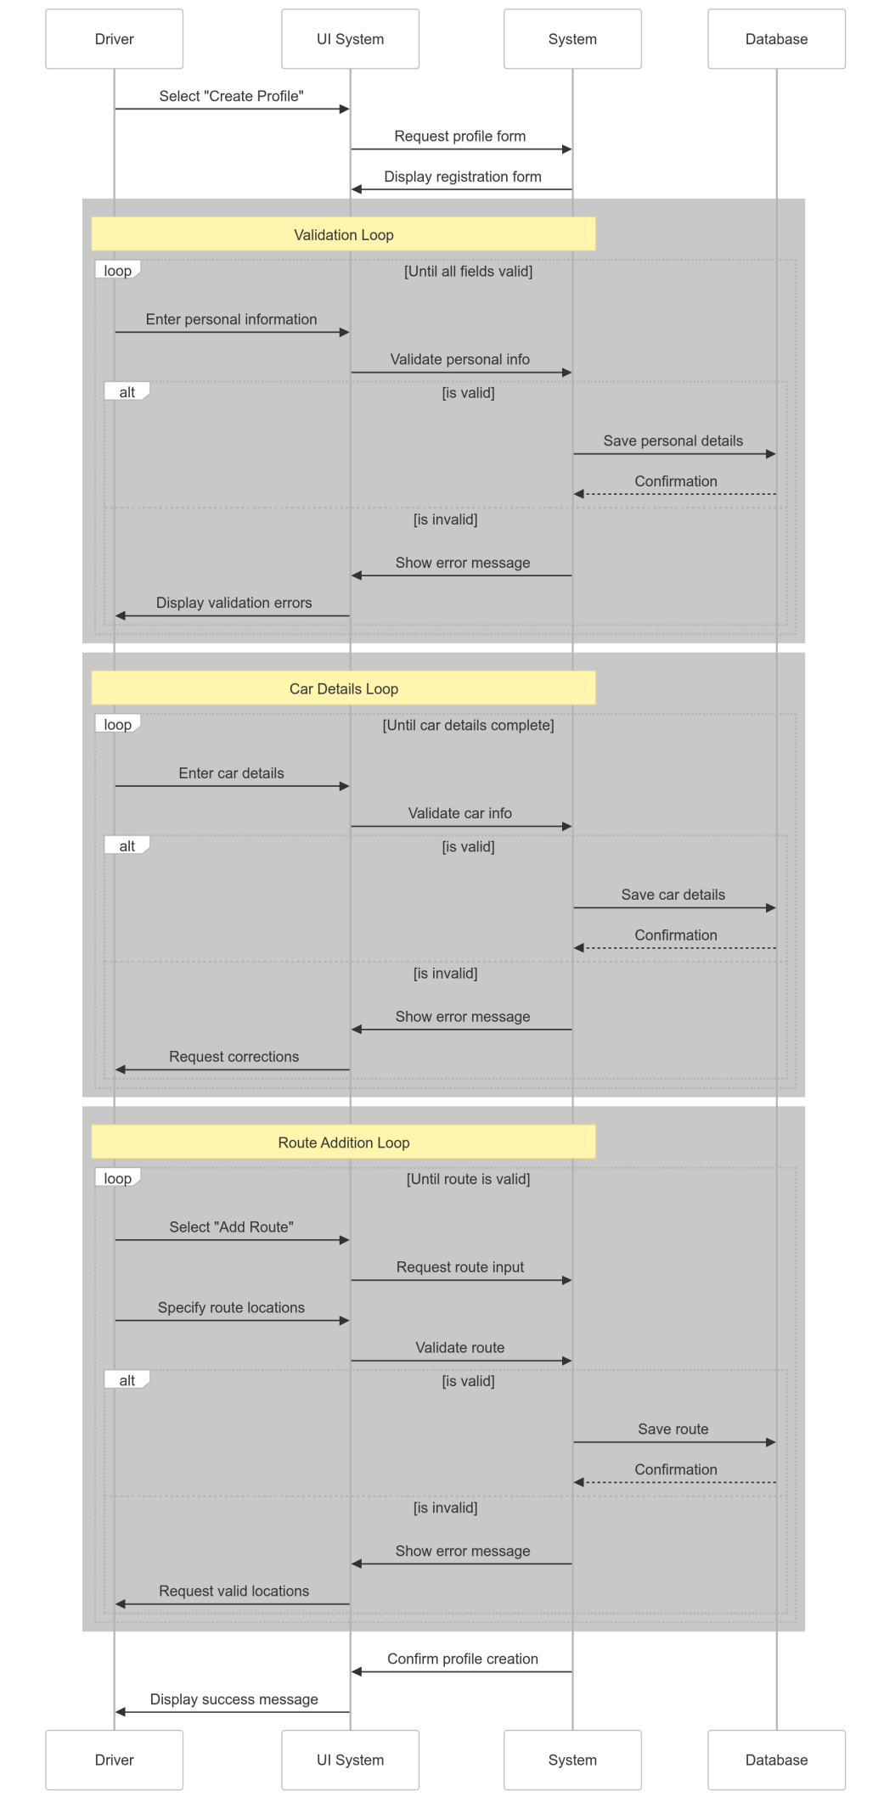

1. **Create Rider Profile**

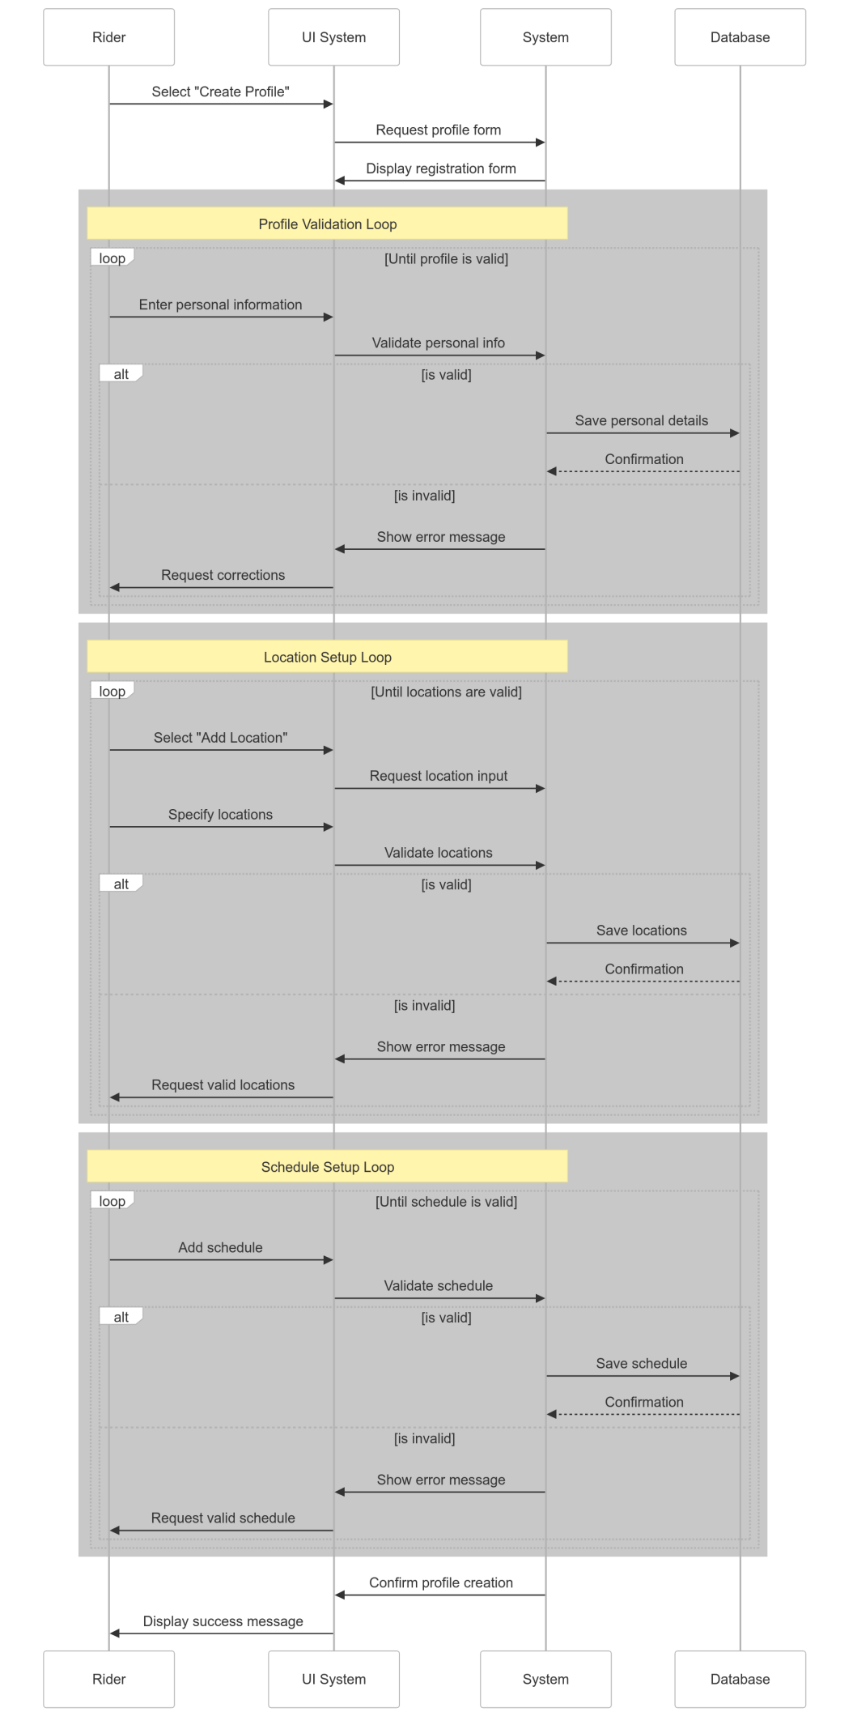

1. **Search for Ride**

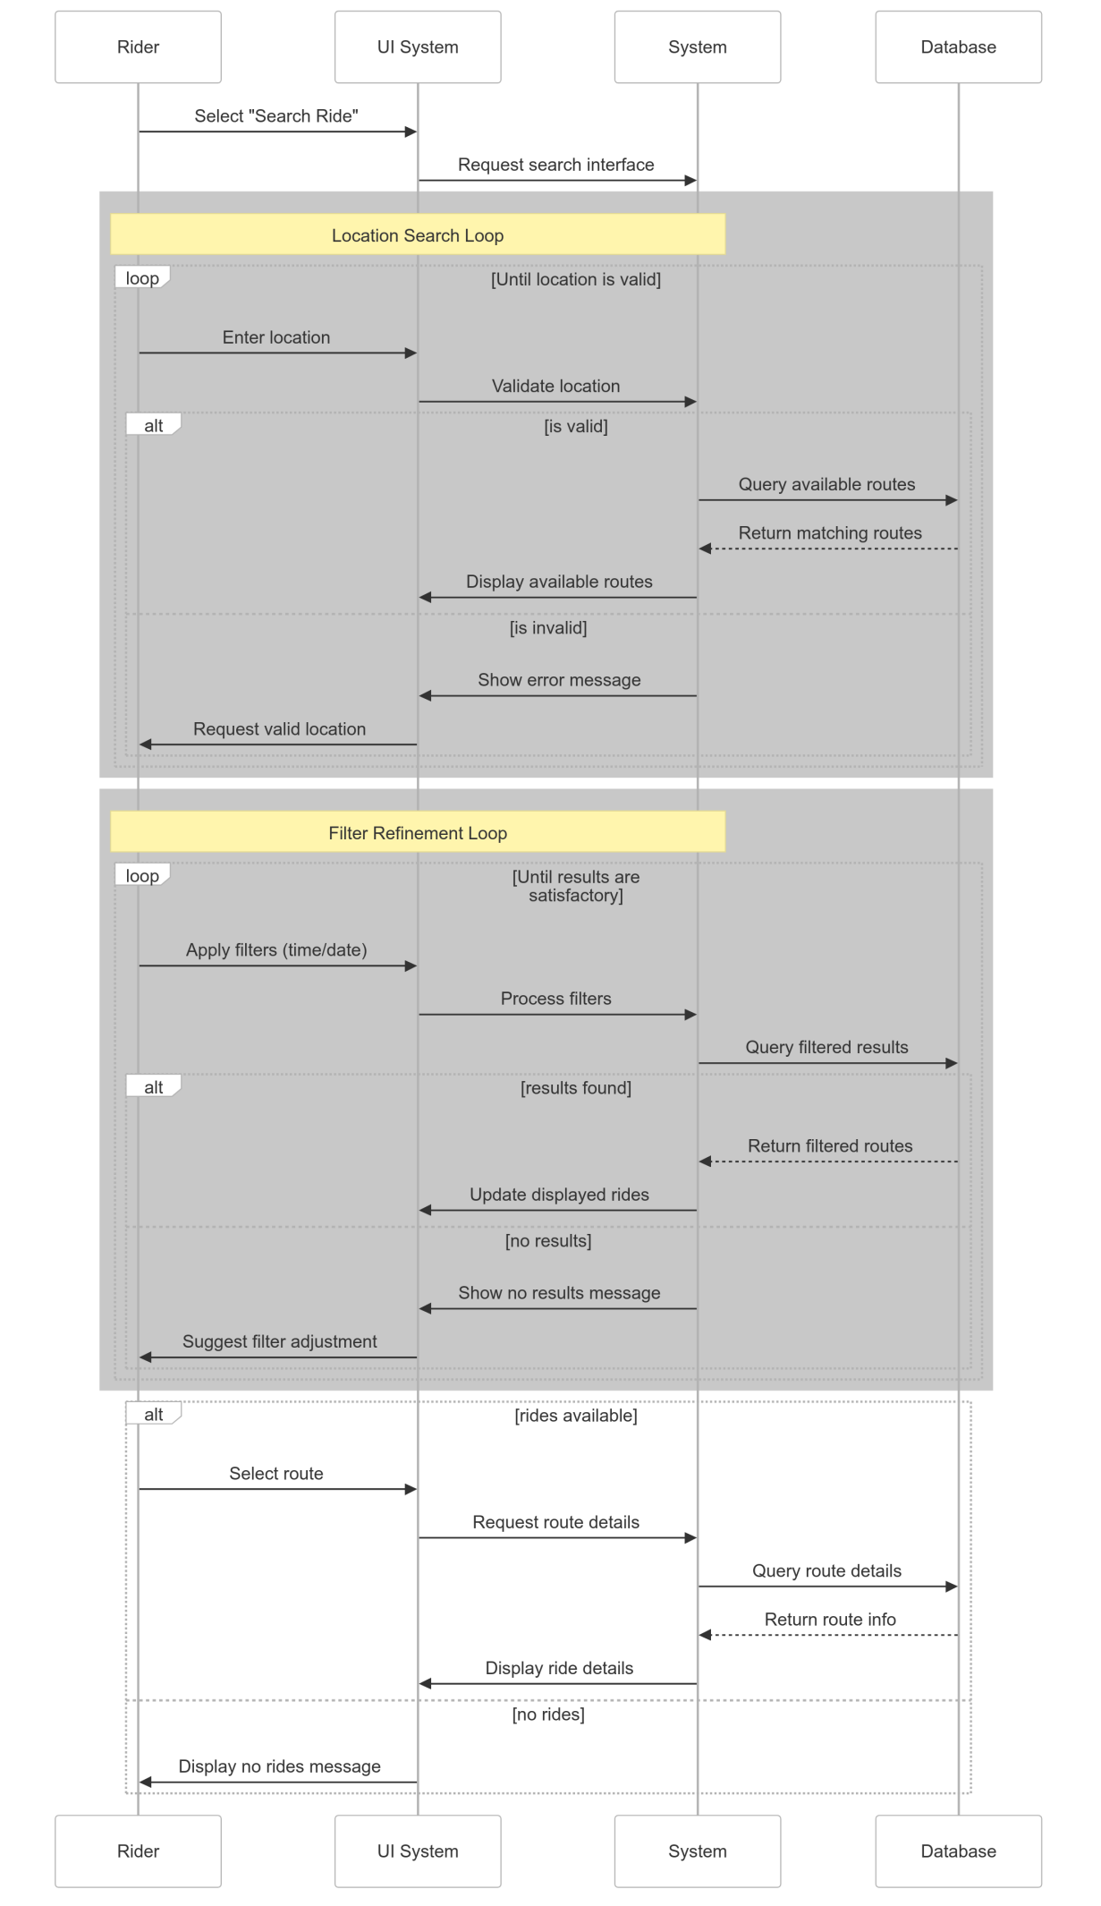

1. **Book or Offer Ride**

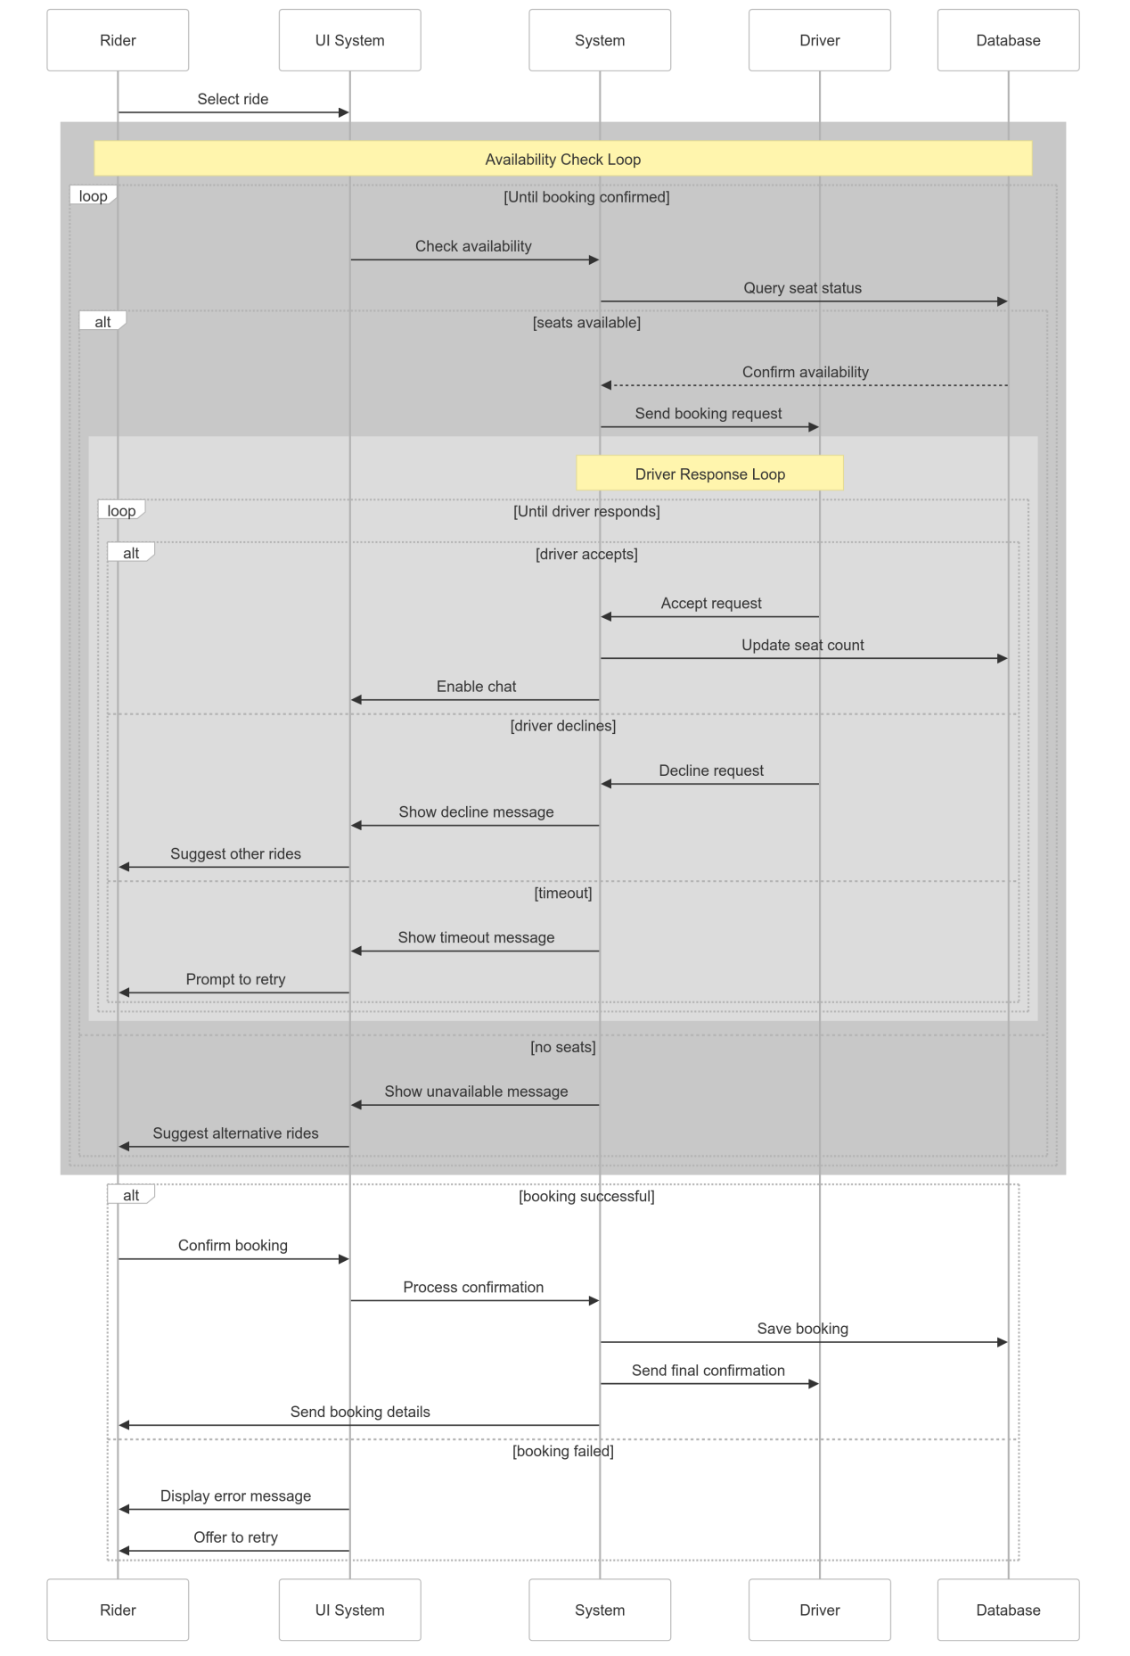

1. **Create and Manage Route**

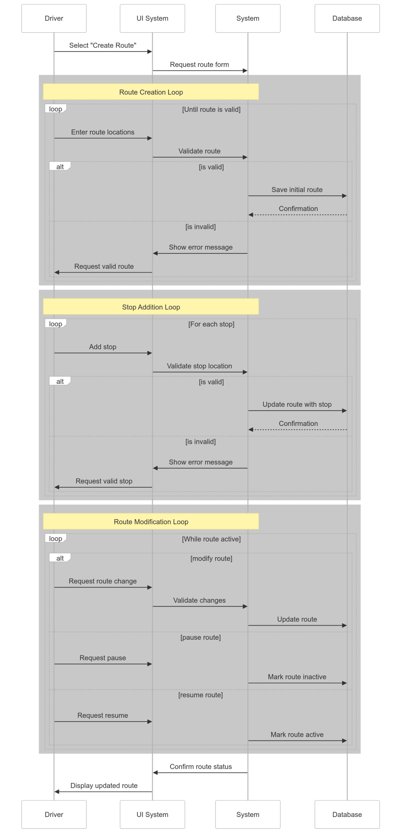

1. **Create and Update Ride Schedule**

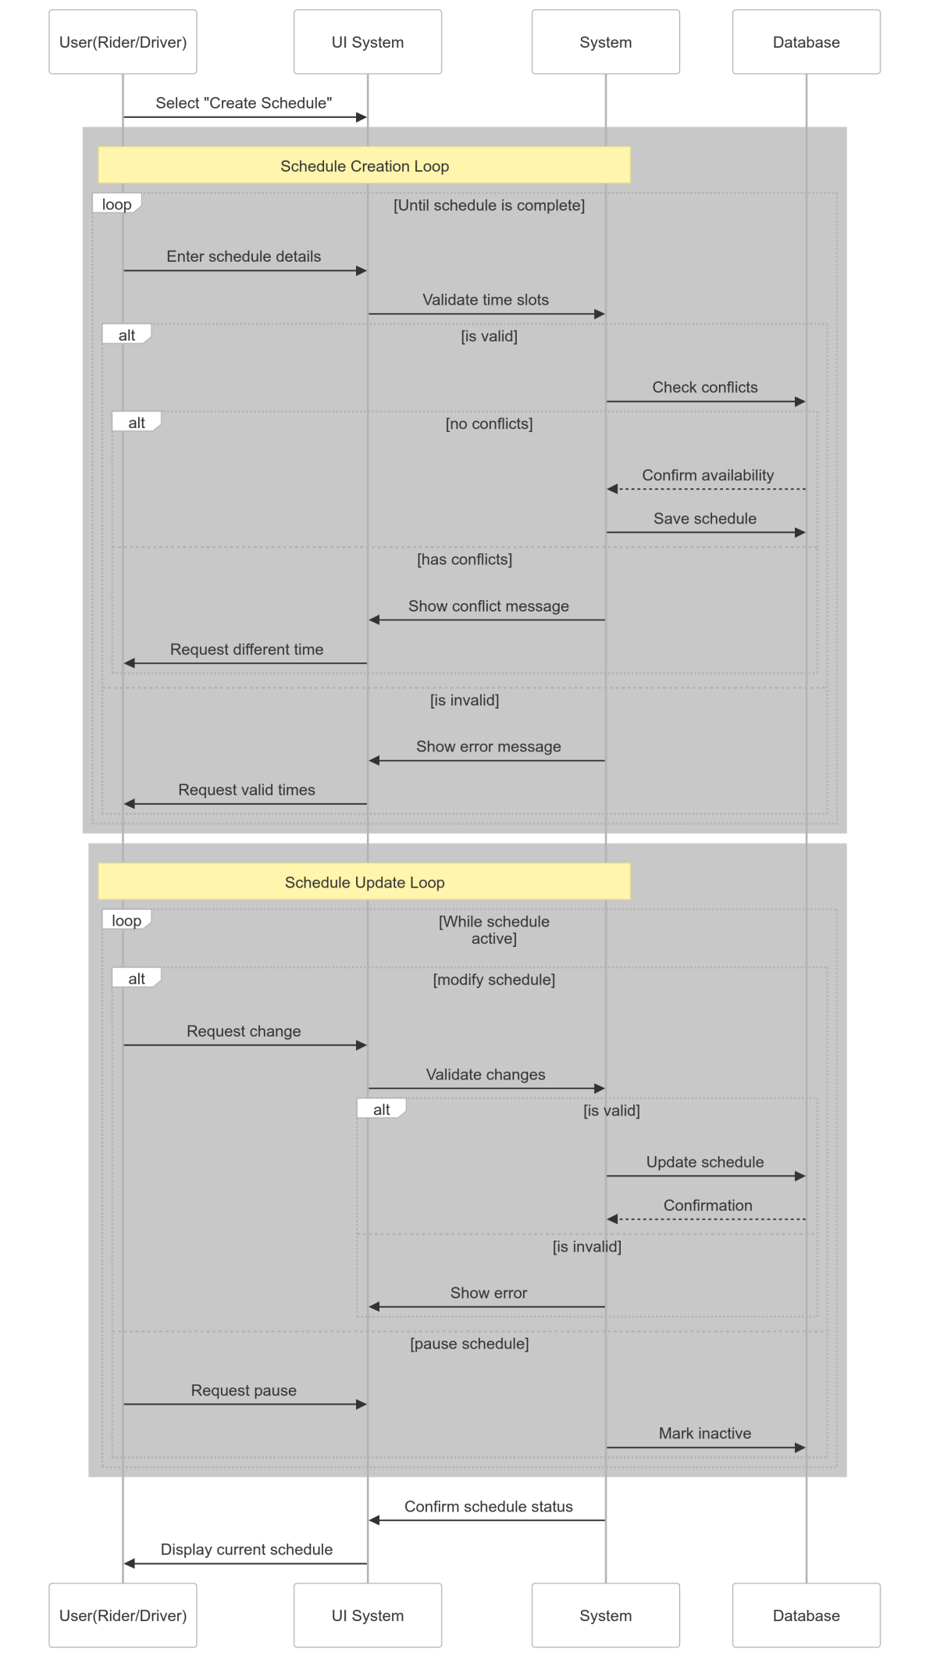

1. **Cancel a Ride**

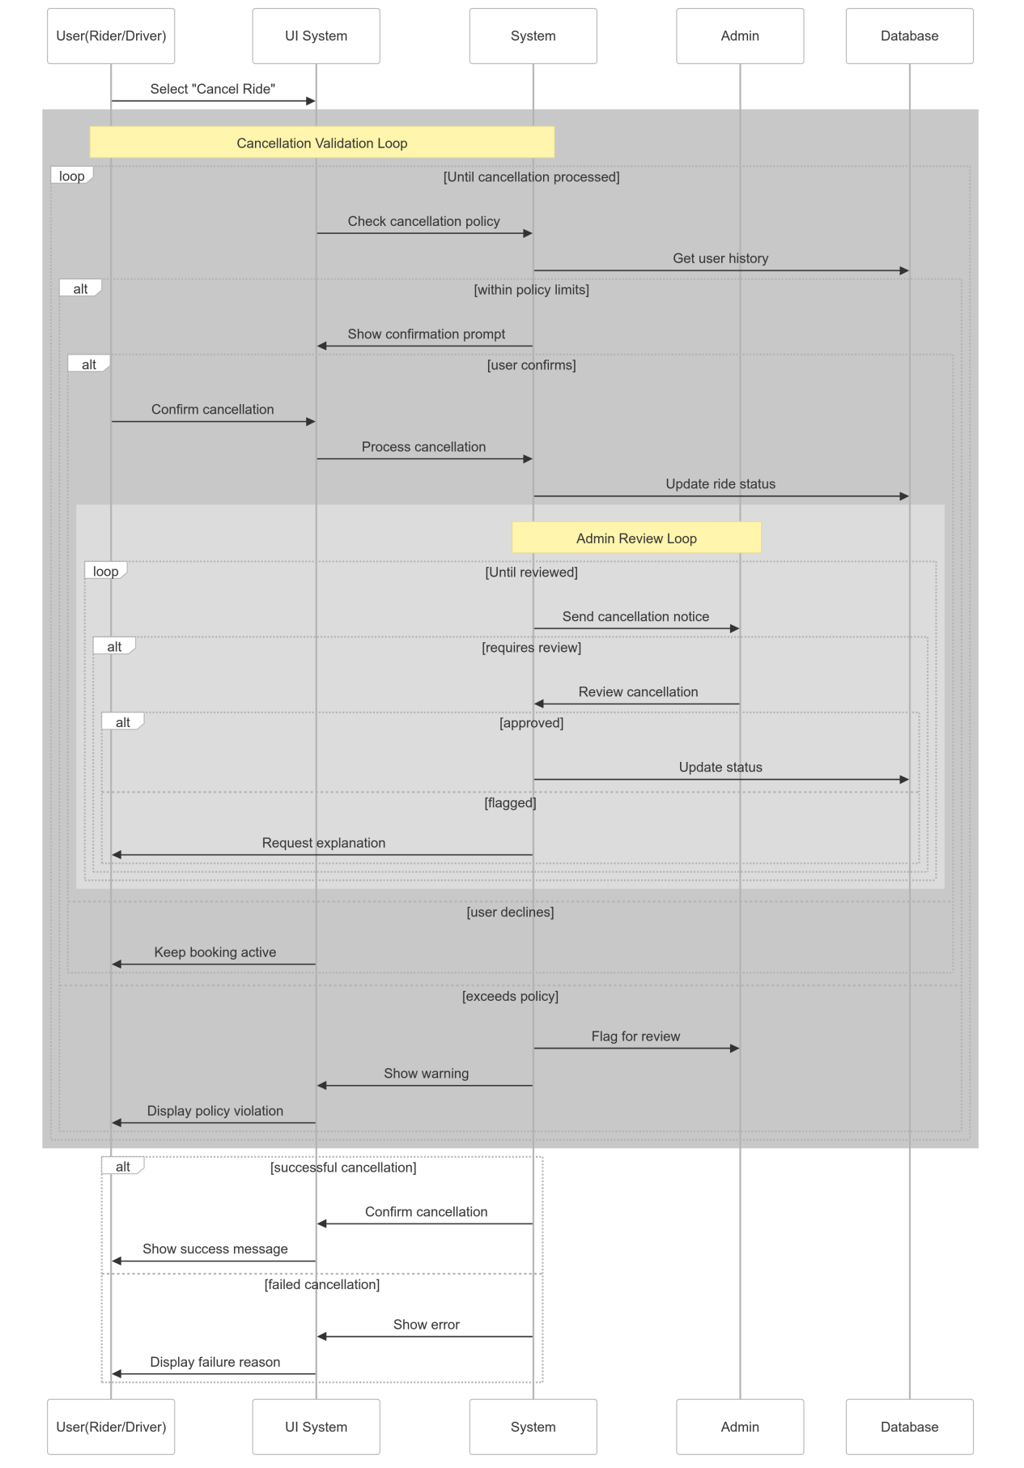

1. **Submit Rating and Feedback**

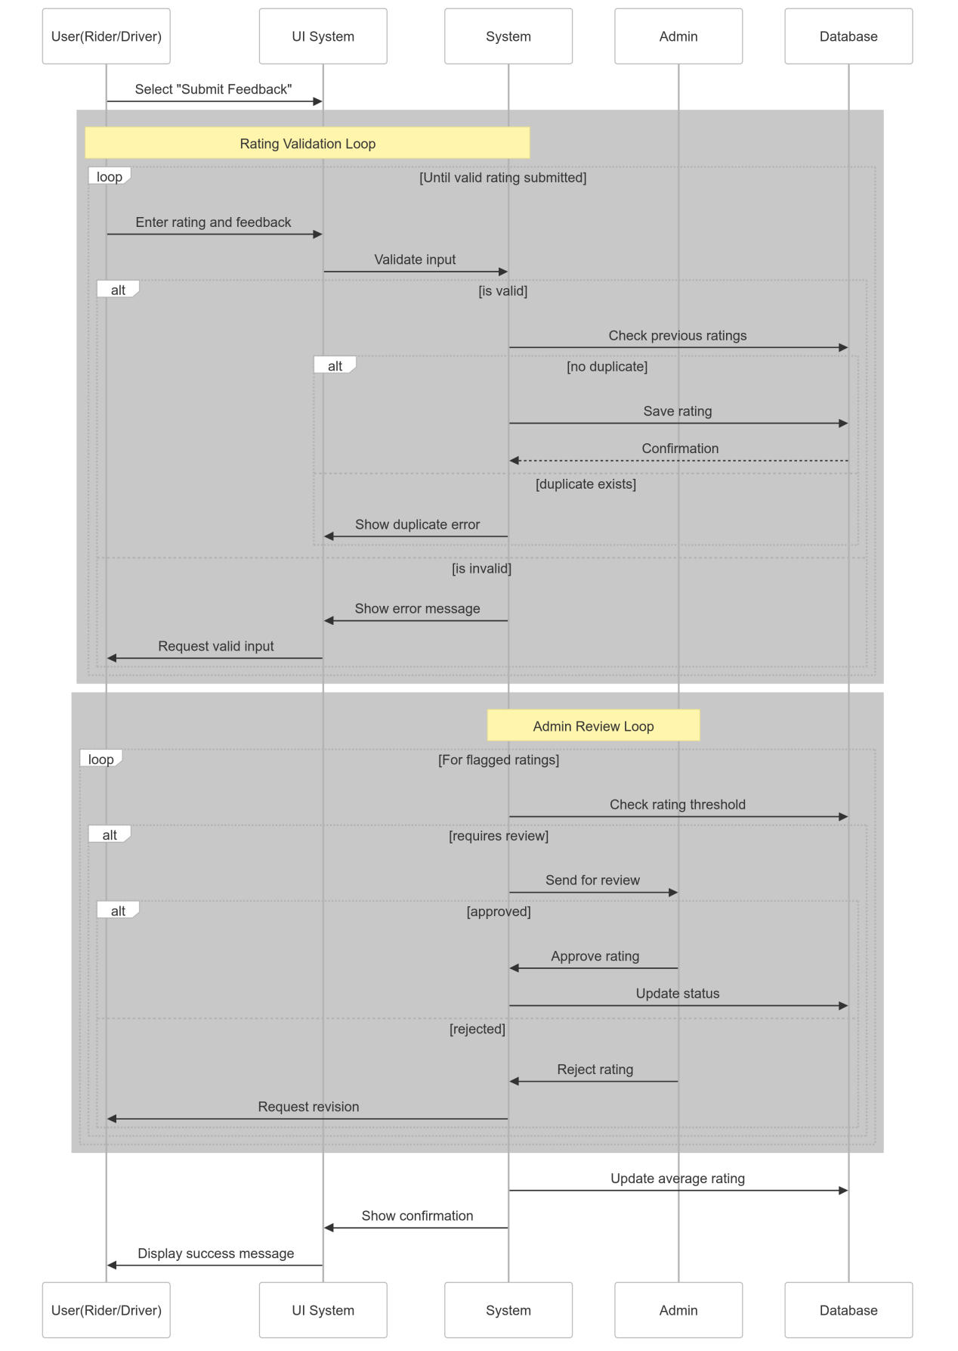

1. **Award and Manage Points**

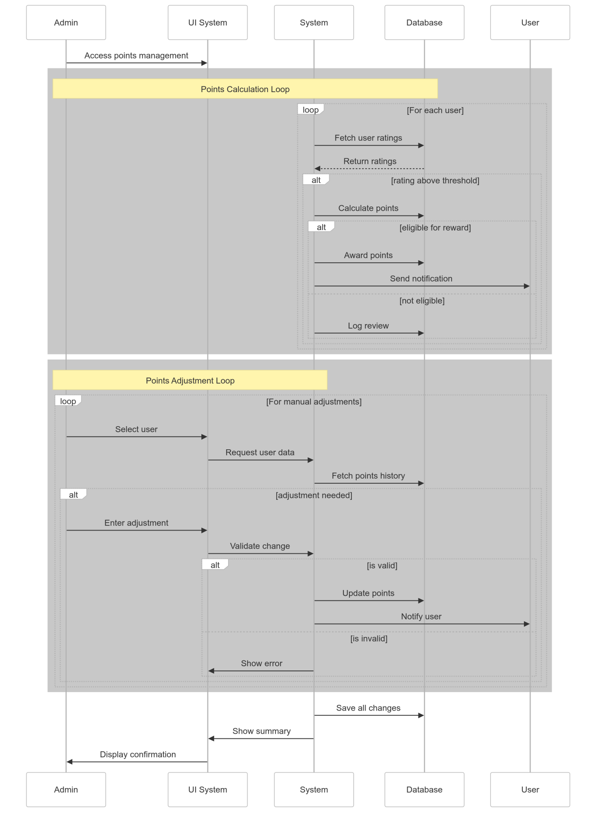

1. **Manage Payment**

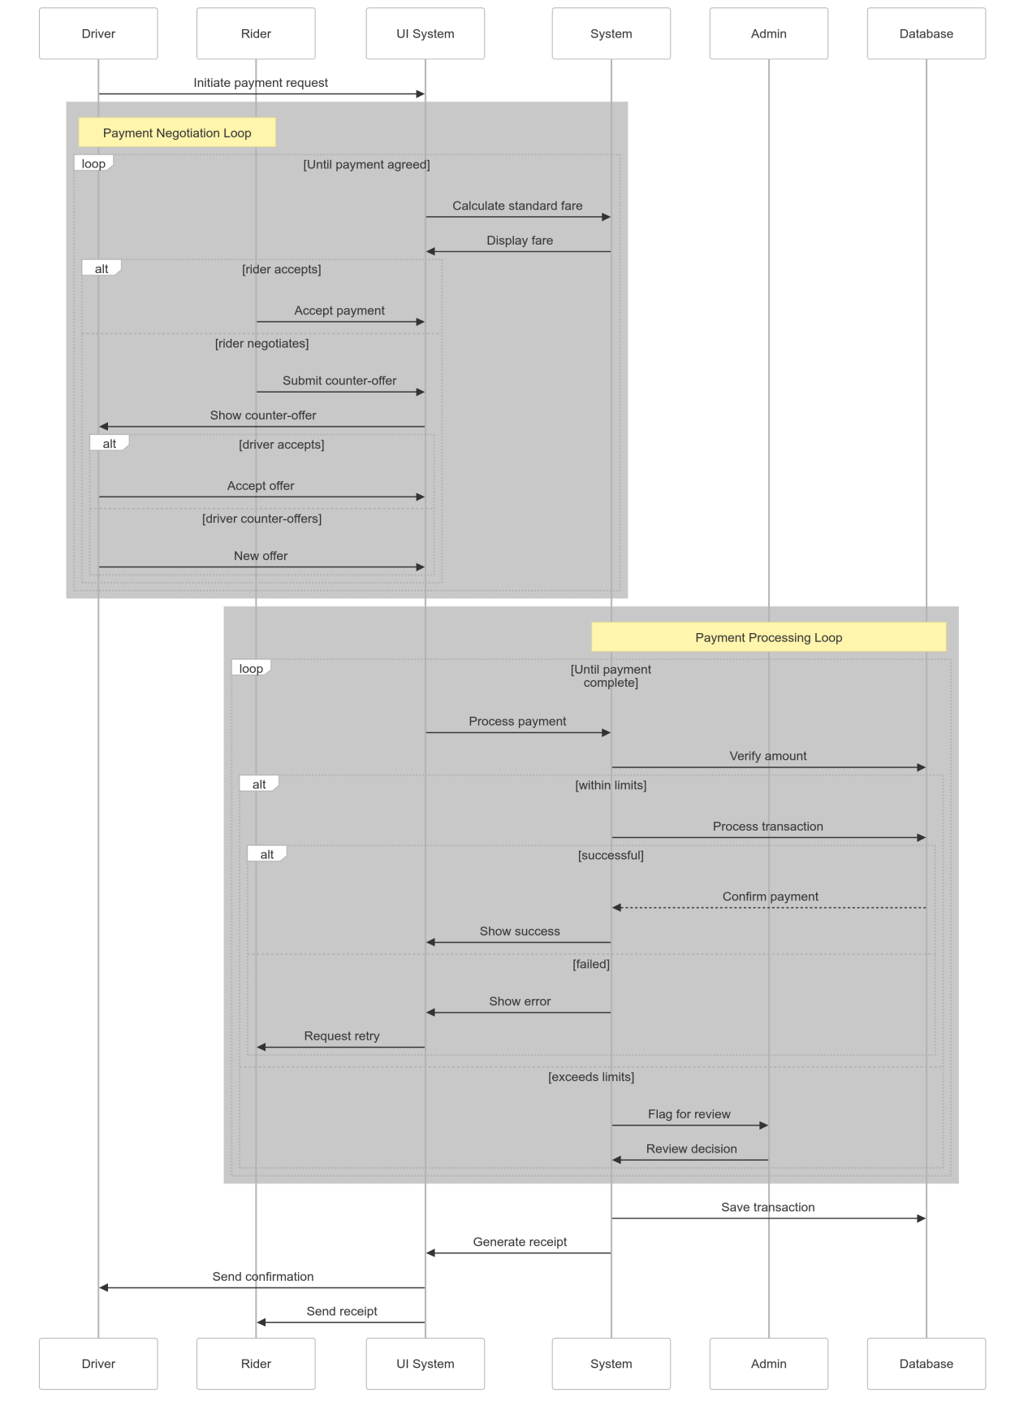

**Class diagram**

